Amy Schofield
Quality Assistant


(January – December 2015)

Quality Statistics: Overview of 2015

CONTENTS

List of tables and graphs  Introduction  2015 Results  Portfolio statistics  General overview of July – September 2015  Tutor portfolio statistics  Feedback statistics: Tutor feedback  Penistone  AMP  Australia  Feedback statistics: Training package, booking process and facilities  Training package feedback  Booking process feedback  Facilities feedback  What candidates felt Lavender International does well  What candidates felt Lavender International could improve on  How did candidates hear about Lavender International?  Would candidates recommend Lavender International?  Concluding remarks | 4-5  6  6  7-13  7-11  12-13  14-17  14-15  16  17  18-22  20  21  22  23-24  25-26  27  28  28-29
Appendices  Appendix A:  This appendix has been removed from general viewing but individual tutors may request sight of their own portfolio completion results. | 30-72  30-49  30
Appendix B  B1: Candidate comments about what Lavender International does well  B2: Candidate comments about what Lavender International could improve on | 50-58  50-53  54-58
Appendix C: Graphs displaying the results for each method for each location | 59-72

List of tables and graphs

tables
Table 1: The actions that have not been completed (non-conformances) in folders and the number of times these actions have not been completed 2015 across the different locations. | 6
Table 2: A comparison of the percentage of non-conforming folders during the first and second six months of 2015. | 12
Table 3: The average tutor score for each method a tutor taught at Lavender Penistone, the total number of responses and the total number of candidates. | 13-14
Table 4: The average tutor score for each method a tutor taught at AMP, the total number of responses and the total number of candidates. | 15
Table 5: The average tutor score for each method a tutor taught at Lavender Australia, the total number of responses and the total number of candidates. | 16
Table 6: A comparison of the number of feedback responses for booking process, training package and facilities during 2015 | 17
Table 7: A comparison of the number of feedback responses for what Lavender International does well, what Lavender International could improve on, how candidates heard about Lavender International and if candidates would recommend Lavender International. | 22

graphs
Fig. 1: A comparison of the number of non-conformances for the first, second, third and fourth quarter of 2015 | 8
Fig. 2: A comparison of the number of non-conformances for the first and second six months of 2015 | 10
Fig 3: A comparison of the overall average score for the training package, booking process and facilities feedback between the first, second, third and fourth quarter of 2015 | 18
Fig 4: A comparison of the overall average feedback score for training package, booking process and facilities feedback for the first and second six months of 2015. | 18
Fig. 5: A bar chart showing the average training package feedback score for each course during 2015. | 19
Fig 6: A bar chart showing the average booking process feedback score for each course during 2015. | 20
Fig 7: A bar chart showing the average facilities feedback score for each course during 2015. | 21
Fig 8: A pie chart showing the percentage of what candidates felt that Lavender International did well during 2015. | 23
Fig 9: A pie chart showing the percentage of what candidates felt that Lavender International could improve on during 2015. | 24
Fig 9: A pie chart showing the percentage of how candidates heard about Lavender International during 2015 | 25

Introduction
The following report provides an overview of the portfolio and feedback statistics between January and December 2015. It should be noted that as the databases for the statistics were first developed in January 2015 and were undergoing constant development, particularly over the first few months of the year, in order to provide more valid and reliable data. With this, some of the data figures may differ slightly in this report to the monthly statistical reports for these months. New databases have been developed for 2016 ready for the start of a new year. All data used in the following report can be found on the results notices, feedback statistics and portfolio statistics database.

2015 Results

Graphs displaying the results for each method for each location can be found in Appendix C.

PORTFOLIO STATISTICS
The following section provides an overview of the portfolio statistics between January and December 2015.

General Overview of JANUARY - DECEMBER 2015
It should be noted that the quality assistant, who usually reviews all of the folders and inputs the data for any incorrect folder onto the system prior to them being processed, was away for nearly 3 and a half weeks during August and September. During this time, folders were processed and a mark was put on the folder so that the quality assistant could check these folders at a later date to ensure that they were complete. Some of these folders were not checked until October 2015; therefore, any incorrect folders from the end of August/September were included in the data for the fourth quarter. This may explain the slight increase in the number of NCRs and NCR folders during the fourth quarter. The number may have actually decreased if the folders from August and September could have been included in the third quarter data as opposed to the fourth.
Table 1: The actions that have not been completed (non-conformances) in folders and the number of times these actions have not been completed during 2015 across the different locations.
Actions | Number of times actions have not been completed during the third quarter (NCR’s)
Actions | Total | Penistone | AMP | Australia | Examiner
Incomplete candidate details | 31 | 29 | 1 | 1
Incomplete exam details | 32 | 31 | 1 | 0 | 32
Incomplete check list section | 264 | 204 | 48 | 12
Incomplete eye test section | 11 | 9 | 1 | 1
Incomplete training details | 5 | 5 | 0 | 0
Incomplete exam results section | 2 | 2 | 0 | 0 | 1
Incomplete attendance register | 11 | 11 | 0 | 0
Incomplete signing off | 79 | 71 | 6 | 2 | 15
Incomplete invigilator check list | 35 | 28 | 6 | 1
Incomplete marking scheme | 108 | 103 | 5 | 0 | 107
Incomplete training workbooks | 226 | 177 | 36 | 13
Total number of NCR’s | 804 | 670 | 104 | 30 | 155
Total number of NCR folders | 569 | 483 | 57 | 29 | 130
Total number of folders | 7094 | 5584 | 1137 | 371 | 3627
% of NCR folders | 8.02% | 8.65% | 5.01% | 7.81% | 3.58%

NOTE: AMP includes folders from the USA and Canada, as tutors from AMP taught courses in these locations; therefore any NCRs from these locations are included in the AMP total. Penistone also processes folders from Oceaneering and offsite locations within the UK; thus any NCRs from these locations are included in the Penistone total. The table shows the total number of folders that tutors have completed and the number of folders that examiners have marked – NOT the total number of candidates.

Between January and December 2015, across all locations (Penistone, AMP and Australia), 569 folders were non-conforming and there were 804 non-conformances (NCRs) within these folders (see Table 1). A breakdown of the NCRs for each location highlight that Penistone had the highest number of NCRs (N = 670) and NCR folders (N = 483) compared to AMP (NCRs = 104; NCR folders = 57) and Australia (NCRs = 30; NCR folders = 29) (see Table 1) during 2015. In terms of percentage, the percentage of incorrect folders across all locations (Penistone, AMP and Australia) was 8.02%. Penistone also had the highest percentage of incorrect folders (8.66%) during 2015, followed by Australia (7.81%); AMP had the lowest percentage (5.01%). Over 2015, the majority of non-conformances were a result of folders having an incomplete checklist (N = 264), an incomplete marking scheme (N= 108) and an incomplete training workbook (N = 226).

The percentage of non-conforming folders decreased over the four quarters by nearly half (Q1 = 10.15%; Q4 = 5.24%) (see Figure 1 and Table A1 in Appendix A). NCRs for incomplete candidate details was high in the second quarter in comparison to the other quarters. This was mainly due to folders from Oceaneering not specifying which company the candidate was from or if they were self-sponsored. This is important for when the folder is scanned onto the system as it determines where the candidate details are stored under. However, after the second quarter it was decided in the quality meeting that these would not be recorded as a non-conformance for Oceaneering folders.
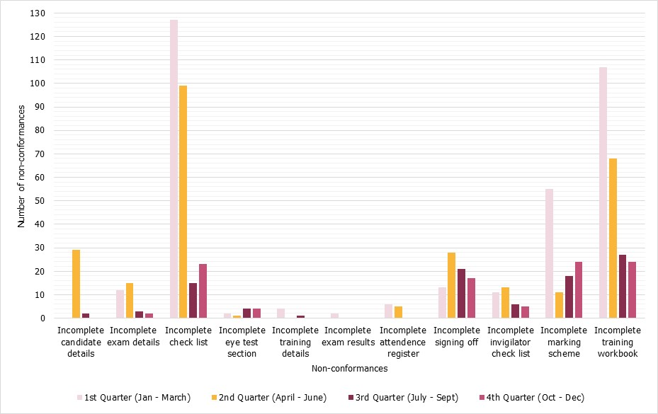
Fig. 1: A comparison of the number of non-conformances for the first, second, third and fourth quarter 2015.
quarter of 2015
The areas that were consistently problematic across the four quarters were:
- An incomplete check list section. This area decreased significantly over the four quarters from 127 in the first quarter to 23 in the fourth. It did increase slight between the third and fourth quarter; however, this may be a result of NCRs from the third quarter being recorded in the fourth (see above)
- An incomplete signing off section. The number of NCRs decreased between the second and third quarter; but was slightly higher in the fourth quarter (N = 17) than in the first (N = 13). Despite this, when comparing the first and second 6 months, NCRs in this area decreased in the second half of 2015 (see Fig. 2 and Table A2 in Appendix A)
- An incomplete marking scheme. The number of NCRs for this area decreased between the first and second quarter; but increased between the second, third and fourth quarter. Despite this increase, the number of NCRs for the fourth quarter (N = 24) is still over half that of the first quarter (N = 55)
- An incomplete training workbook. Despite being a consistently problematic area, this area has seen the greatest improvement, with the number of NCRs decreasing across all quarters from 107 in the first quarter to 24 in the fourth. This decrease is even more pronounced when comparing the number of NCRs for this area for the first half of the year (N = 175) to the second half of the year (N = 51) (see Fig. 2 and Table a2 in Appendix A).

Despite the above areas being of greatest concern, the percentage of NCR folders has greatly decreased between the first (10.31%) and second (5.33%) 6 months of the year (see Fig. 2 and Table A2 in Appendix A). This is evident when looking at the number of NCRs, which have decreased for every area between the first and second half of the year, apart from for the eye test section (first 6 month = 3; second 6 month = 8). However, the increase in this area is small in comparison to the total number of folders and should not be considered an area of concern. This could suggest that the quality of folder completion has improved as a result of individuals becoming more careful and vigilant when completing their folders.

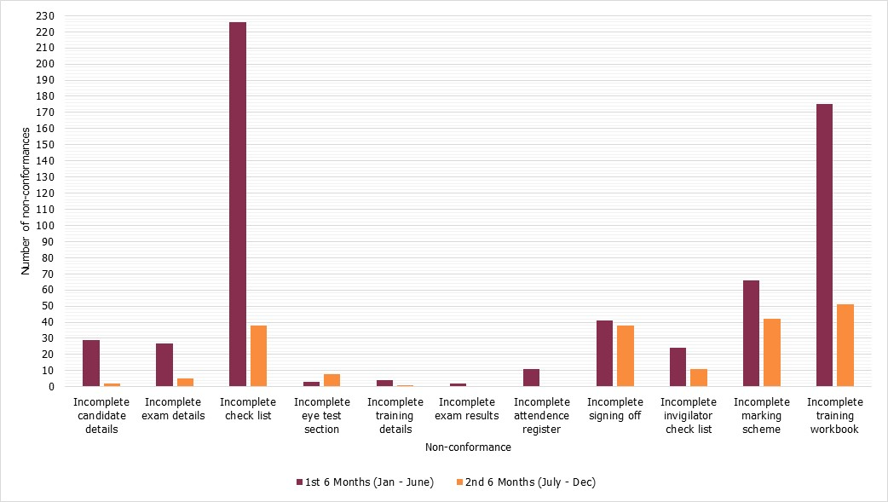
Fig. 2: A comparison of the number of non-conformances for the first and second 6 months of 2015.
quarter of 2015

TUTOR PORTFOLIO STATISTICS
Tables in Appendix A (A3, A4, A5 and A6) provide a breakdown of the NCRs for each tutor and examiner at Penistone, AMP and Australia. As seen earlier, when accounting for both tutors and examiners, Penistone had the highest percentage of NCR folders. Penistone also had the highest percentage of NCR folders (15.8%; see Table A3 in Appendix A) when looking at folders completed by tutors independently, followed by Australia (9.42%; see Table A5 in Appendix A), and AMP had the lowest percentage(5.81%; see Table A4 in Appendix A).

After the quality meeting in June, it was decided that a target of 95% correct folders by the end of the year for tutors and examiners who had completed at least 25 folders should be set, so as to encourage tutors and examiners to be more careful when completing their folders. All tutors and examiners who had 5% of non-conforming folders or less are highlighted in yellow within the tables (see Appendix A). All examiners and tutors who taught UT at AMP completed folders correctly over 95% of the time during 2015, thus their completed folders were within the set target range. However, other tutors at Penistone, AMP and Australia had a percentage of non-conforming folders that was greater than 5%; therefore their percentage of non-conforming folders did not meet the set target of completing 95% of their folders correctly.

Despite this, the total number of NCRs and NCR folders greatly decreased in the second half of 2015 (See Table A2 in Appendix A); and when comparing the percentage of non-conforming folders per tutor/examiner, it had decreased for the majority of tutors and examiners during the second half of the year in comparison to the first (see Table 2). This could suggest that individuals have become more careful in completing their folders correctly as a result of methods enforced by the Quality Department. For example, tutors and examiners were asked to come to the quality office and complete their folder if it was submitted incomplete; they were made aware of how the folders should be completed; and they were made aware of any NCRs that they have obtained over the month (when the reports were conducted monthly). In addition, several individuals completed folders correctly over 95% of the time, which could suggest that setting a percentage target did in fact encourage individuals to pay more attention to completing their folders correctly.

Table 2: A comparison of the percentage of non-conforming folders during the first and second six months of 2015
= Percentage of non-conforming folders that were lower than the first half of 2015
Location | Tutor | Percentage of non-conforming folders
Location | Tutor | First 6 months (January – June) | Second six months (July – December) | Met the 95% correct folder target during second six months
Penistone | Andrew Waller | 26.67% | 10.71%
Penistone | Andy Greenwood | 21.18% | 12.31%
Penistone | Becky Roberts | 10.67% | 7.14%
Penistone | Chris Boreham | 9.59% | 4.85% | YES
Penistone | Chris Sykes | 15.69% | 4.38% | YES
Penistone | Ian Griffin | 31.71% | 9.09%
Penistone | Neil Samson | 65.38% | 17.65%
Penistone | Peter Oliver | 53.10% | 18.31%
Penistone | Phil Hall | 20.37% | 11.27%
Penistone | Rachel Wood | 13.13% | 10.2%
Penistone | Roger Hamlett | 12.5% | 6.98%
Penistone | Tom Dart | 13.7% | 4.23% | YES
Australia | Paul Lavender | 12.73% | 11.32%
Australia | Warren Villarosa | 7.02% | 9.3%
AMP | Andrew King | 13.16% | 0% | YES
AMP | David Miller | 27.27% | 12.7%
AMP | UT | 1.64% | 1.38% | YES
AMP | Rob Buckle | 21.88% | 2.86% | YES
AMP | Tim Armitt | 19.23% | 16.13%
Examiners | Dave Lavender | 4.9% | 3.91% | YES
Examiners | Ian Griffin | 5.65% | 0.59% | YES
Examiners | Roger Hamlett | 1.71% | 0% | YES
Examiners | Paul Lavender | 0% | 0% | YES
Examiners | Andrew King | 0% | 0% | YES
Examiners | David Miller | 0% | 3.7% | YES
Examiners | Tim Armitt | 19.23% | 5.26%

FEEDBACK STATISTICS: TUTOR FEEDBACK
The following section provides an overview of the tutor feedback statistics between January and December 2015. The overall tutor average score for Lavender Penistone, Australia, USA, Canada and AMP during 2015 was 4.88. The total number of feedback responses for tutor feedback score was 1403. The following tables (Table 3, 4 and 5) provide a breakdown of feedback scores for each tutor.

Penistone
During 2015, the overall average score for tutors at Penistone was 4.92, which exceeds the set target of 4. Each tutor received an average score that was between 4 and 5 (good or excellent) for each method that they taught (see Table 3). The number of responses for 2015 was 885, suggesting that the overall tutor average score reliable.

Table 3: The average tutor score for each method a tutor taught at Lavender Penistone, the total number of responses and the total number of candidates.
Tutor | Method | Score | Number of responses | Total number of candidates
ANDREW WALLER | ACFM  ET  MT  PT | 5  4.93  4.91  5  4.93 | 1  56  11  2  70 | 146
ANDY GREENWOOD | RT  CRT  BRS  RPS | 4.95  5  5  5  4.97 | 56  8  27  11  102 | 150
ANDY YOUNG | VT  UT | 4.71  5  4.80 | 7  3  10 | 7
BECKY ROBERTS | RT  CRT  BRS | 5  4.5  5  4.99 | 58  2  12  72 | 145
CHRIS BOREHAM | MT  PT | 4.94  4.70  4.91 | 125  20  145 | 249
CHRIS SYKES | MT  PT  VT | 4.8  4.65  4.8  4.76 | 49  20  5  74 | 434
IAN GRIFFIN | PT  VT  WI | 4.86  4.85  4.83  4.85 | 7  33  6  46 | 74
MARTIN LUGG | ACFM | 4.8 | 5 | 4
NEIL SAMSON | VT | 4.92 | 26 | 43
PAUL JONES | UT | 4.67 | 3
PETER OLIVER | MT  PT | 5  4.93  4.95 | 12  61  73 | 287
PHIL HALL | MT  PT  RT  BRS  RPS  (Penistone Average)  (Overall average including UT) | 5  5  5  5  5  5  (4.99) | 16  9  18  9  4  56  (70) | 125
RACHEL WOOD | MT  PT | 5  4.99  4.99 | 25  88  113 | 258
ROGER HAMLETT | BASIC  ET  MT  RT  VT  UT | 5  5  5  5  5  4.67  4.94 | 1  6  3  2  1  3  16 | 166
STEVE FIELDING | WI | 5 | 1 | 2
TOM DART | RT  BRS  RPS | 4.77  4.92  5  4.82 | 54  13  6  73 | 144
 | 2015 | 4.92 | 886 | 2234
 | 4TH Quarter | 4.92 | 208 | 501
 | 3rd Quarter | 4.91 | 233 | 484
 | 2nd Quarter | 4.92 | 286 | 600
 | 1st Quarter | 4.91 | 159 | 649

AMP
During 2015, the overall average tutor score at Lavender AMP was 4.82, which exceeds the set target score of 4. Each tutor received an average score that was between 4 and 5 (good or excellent) for each method that they taught (see Table 4). The number of responses for 2015 was 367, suggesting that the overall average feedback score is reliable.

Table 4: The average tutor score for each method a tutor taught at AMP, the total number of responses and the total number of candidates.
Tutor | Method | Score | Number of responses | Total number of candidates
ANDREW KING | UT  PA  TOFD | 4.85  4.91  4.84  4.87 | 5  23  19  47 | 69
CHRIS BALL, JOHN TREWEEK AND NOEL BOSTWICK | UT | 4.68 | 139 | 595
DAVID MILLER | UT  PA  TOFD | 5  5  4.8  4.98 | 19  28  5  52 | 107
PHIL HALL | UT | 4.93 | 14 | (Joint UT course with Rob)
ROB BUCKLE | UT  PA  TOFD | 4.82  4.88  4.71  4.81 | 31  16  14  61 | 67
TIM ARMIT | MT  UT  PA  TOFD | 5  5  5  4.8  4.96 | 7  8  29  10  54 | 57
 | 2015 | 4.82 | 367 | 895
 | 4th Quarter | 4.88 | 103 | 225
 | 3rd Quarter | 4.79 | 93 | 195
 | 2nd Quarter | 4.83 | 128 | 226
 | 1st Quarter | 4.75 | 43 | 219

Note: As tutors from AMP also run courses in the USA, Canada and Australia, the scores from all four locations have been collated. This is because the scores are supposed to reflect the teaching ability for the method that the tutor taught and not the location.

Australia

During 2015, the overall average tutor score for Australia was 4.75, which exceeds the set target score of 4. Both tutors at Lavender Australia received an average score that was between 4 and 5 (good or excellent) for each method that they taught (see Table 5). The number of responses for 2015 was 151, suggesting that the overall tutor average score is reliable.

Table 5: The average tutor score for each method a tutor taught at Lavender Australia, the total number of responses and the total number of candidates.
Tutor | Method | Score | Number of responses | Total number of candidates
PAUL LAVENDER | ACFM  ET  MT  PT  UT | 4.83  4.9  4.64  5  4.79  4.8 | 6  10  7  1  19  43 | 108
WARREN VILLAROSA | MT  PT  RT  UT | 4.62  4.84  4.67  4.85  4.73 | 45  31  12  20  108 | 200
 | 2015 | 4.75 | 151 | 308
 | 4th Quarter | 4.83 | 26 | 61
 | 3rd Quarter | 4.81 | 42 | 78
 | 2nd Quarter | 4.67 | 69 | 93
 | 1st Quarter | 4.86 | 14 | 76

FEEDBACK STATISTICS: TRAINING PACKAGE, BOOKING PROCESS AND FACILITIES
The following section provides an overview of the feedback statistics for training package, booking process and facilities during 2015. It is evident that there was an increase in the overall average feedback score for training package (TP) booking process (BP) and facilities between the first and second six months of 2016 (see Fig. 4), suggesting an improvement in these areas. This increase is more pronounced when comparing the four quarters separately; highlighting that the overall average feedback scores for TP, BP and facilities have increased over the four quarters of 2015 (see Fig. 3). BP had the greatest increase in feedback score of 0.12 between the first and fourth quarter (Q1 = 4.59; Q4 = 4.71). The feedback score for Facilities increased by 0.11 and TP increased by 0.09 (Q1 = 4.65, Q4 = 4.74) between the first and fourth quarter (Q1 = 4.52; Q4 = 4.63).

The number of feedback responses for booking process, training package and facilities was high across all quarters, suggesting that the feedback scores are likely to be reliable (see Table 6). The number of responses increased between the first and second quarter, but decreased between the second, third and fourth quarter. This may be a result of less candidates coming to Lavender’s during this period.
Table 6: A comparison of the number of feedback responses for booking process, training package and facilities during 2015
 | Number of feedback responses
Quarter | Booking process | Training package | Facilities
1 | 233 | 240 | 239
2 | 413 | 432 | 433
3 | 333 | 345 | 345
4 | 311 | 322 | 317
Total 2015 | 1290 | 1339 | 1334
First 6 months (January – June) | 646 | 672 | 672
Second 6 months  (July – December) | 644 | 667 | 662

Fig. 3: A comparison of the overall average score for the training package, booking process and facilities feedback between the first, second, third and fourth quarter.
Fig. 4: A comparison of the overall average feedback score for the training package, booking process and facilities between the first and second six months of 2015.

Training package feedback

The overall average training package (TP) score for all courses and locations during 2015 was 4.67. There were 1339 responses (see Table 6), therefore it could be suggested that the feedback score is reliable. The highest TP score was in the fourth quarter (4.74) and the lowest was in the second quarter (4.63) (see Fig. 3). During 2015, all courses had an overall average TP feedback score that was equal to or greater than the set target of 4. The Basic Level 3 course had the lowest average score (4; see Fig. 5); however, there was only one feedback response and so the feedback score reliability for this method is questionable. The BRS course had the highest feedback score (4.88); and it could be suggested that this score is reliable due to having a considerable amount of feedback responses (N = 60). The MT (N = 296), PT (N = 233) and UT (N = 233) courses had the highest number of feedback responses, possibly because there were a higher number of candidates on these courses, and so it could be suggested that the feedback scores for these courses are reliable.
Fig. 5: A bar chart showing the average training package feedback score for each course during 2015.

Booking Process Feedback
The overall average booking process (BP) score for all courses and locations during 2015 was 4.65. There were 1290 responses (see Table 6), therefore it could be suggested that the feedback score is reliable. The highest BP score was in the fourth quarter (4.71) and the lowest was in the first quarter (4.59) (see Fig. 3). During 2015, all courses had an overall average BP feedback score that was greater than the set target of 4. The TOFD course had the lowest average score (4.44; see Fig. 6); and it could be suggested that this score is reliable due to having a considerable amount of feedback responses (N = 45). Despite TOFD having the lowest feedback score, it still exceeds the set target of 4. The Basic Level 3 course had the highest feedback score (5); however, there was only one feedback response and so the feedback score reliability for this method is questionable. The MT (N = 296), UT (N = 226) and PT (N = 215) courses had the highest number of feedback responses during 2015, possibly because there were a higher number of candidates on these courses, and so it could be suggested that the feedback scores for these courses are reliable.
Fig. 6: A bar chart showing the average booking process feedback score for each course during 2015.

Facilities Feedback
The overall average facilities score for all methods and locations was 4.57 during 2015. There were 1334 responses (see Table 6), therefore it could be suggested that the feedback score is reliable. The highest facilities score was in the fourth quarter (4.63) and the lowest was in the first quarter (4.52) (see Fig. 3). During 2015, all courses had an overall average facilities feedback score that was equal to or greater than the set target of 4. The Basic Level 3 course had the lowest average score (4; see Fig. 7); however, there was only one feedback response and so the feedback score reliability for this method is questionable. The PA course had the highest feedback score (4.83); and it could be suggested that this score is reliable due to having a considerable amount of feedback responses (N = 84). The MT (N = 295), PT (N = 238) and UT (N = 227) courses had the highest number of feedback responses during 2015, possibly because there were a higher number of candidates on these courses, and so it could be suggested that the feedback scores for these courses are reliable.

Fig. 7: A bar chart showing the average facilities feedback score for each course during 2015.

WHAT CANDIDATES FELT LAVENDER INTERNATIONAL DOES WELL
All comments from candidates relating to this question from the fourth quarter can be found in Appendix B1. Comments relating to the first, second and third quarter can be found in the first six month and third quarter reports. During 2015, nearly 50% of candidate responses said that Lavender International provided good and/or knowledgeable teaching (N = 476) (see Fig. 8); with candidates frequently commenting on the level of knowledge of the tutors, the level of support that was given, the style of teaching, how the training materials were presented and how well concepts were explained were comments frequently given by candidates. 15% of candidates said that Lavender International provided a relaxed/friendly environment (N = 151); with candidates frequently commenting on the friendliness and approachability of all staff members, how helpful members of staff were and that staff made candidates feel welcome. 12% (N = 115) of candidates thought that Lavender International does everything well.
Table 7: A comparison of the number of feedback responses for what Lavender International does well, what Lavender International could improve on, how candidates heard about Lavender International and if candidates would recommend Lavender International.
 | Total number of feedback responses
Quarter | What LI does well | What LI could improve on | How candidates heard about LI | Would candidates recommend LI
1 | 146 | 125 | 209 | 241
2 | 347 | 218 | 353 | 445
3 | 267 | 175 | 288 | 347
4 | 229 | 128 | 267 | 324
2015 | 989 | 646 | 1117 | 1359
First 6 months (January – June) | 493 | 343 | 562 | 686
Second 6 months  (July – December) | 496 | 303 | 555 | 673

Fig 8: A pie chart showing the percentage of what candidates felt that Lavender International did well during 2015.

WHAT CANDIDATES FELT LAVENDER INTERNATIONAL COULD IMPROVE ON
All comments from candidates relating to this question for the fourth quarter can be found in Appendix B2. Comments relating to the first, second and third quarter can be found on the feedback database and third quarter report. All comments have been reviewed by the Quality Assistant and the Business Manager, and if need further action is required, they were passed to the line manager and/or Stephen Lavender.

During 2015, the majority of candidates (N = 283) said that Lavender International did not need to improve in any area (see Fig. 9). However, 11% of candidates felt that the facilities could be improved. A dominant theme for facilities was that there is limited parking availability at the Penistone site. This is currently being discussed by the SMG in an attempt to resolve this issue. Furthermore, some responses about improving the facilities came from Australia, placing emphasis on moving to bigger and better facilities. Lavender International moved location to new facilities in Australia towards the end of 2015 and so the number of responses relating to improving the facilities in Australia should decrease in 2016. Moreover, candidates have suggested that the men’s toilets are in need of refurbishment; which has been discussed by the SMG.

In addition, 9% of candidates have commented on improving the training materials provided by Lavender International during 2015. Comments relating to the ACFM course were from the first ACFM course that was run and therefore any comments relating to training material provided constructive feedback for the next ACFM course. Moreover, several of these comments between January and October related to changing the PA course notes from black and white to colour. The PA notes were updated and distributed during the fourth quarter; thus any comments relating to this issue should have reduced.

Furthermore, 8% of candidate comments related to improving practical material/workshops. During the second quarter, candidates stated that the RT training materials/workshops in Penistone needed to be improved, such as the quality of the radiographs. This issue was discussed in the June Quality meeting and brought to the attention of the head of the RT department, who has since updated them. During the third quarter, none of the feedback responses related to improving RT training materials/workshops, which could suggest that this is no longer an issue of concern.

Moreover, during 2015 8% of candidates suggested that having food facilities on the Penistone site “would be beneficial” so that “less time is spent in town”. Candidates coming to Lavender International have provided a source of income to shops and cafes in the local community; and because they are only a short walk away from the Penistone site, the company initially did not feel the need to provide food facilities on site. However, as this theme has reoccurred over 2015, providing some sort of food facilities is currently being looked into by the SMG.
Fig 9: A pie chart showing the percentage of what candidates felt that Lavender International could improve on during 2015.

HOW DID candidates HEAR ABOUT LAVENDER INTERNATIONAL?
The number of responses to this question for 2015 was 1359. Over 50% of candidates heard about Lavender’s through their company/work place (N = 364), work colleagues, family or friends (N = 224) (see Fig. 10). 16% of candidates said that they had heard about Lavender International via word of mouth and 21% have been to Lavender’s before. With this, it could be suggested that Lavender International has built up a reputation such that individuals in the industry recommend Lavender International for training to others.
Fig 10: A pie chart showing the percentage of how candidates heard about Lavender International during 2015.

Would candidates recommend Lavender International?

During 2015, 99.7% of candidates said that they would recommend Lavender International!
(1355/1359 responses. One candidate said that they would not recommend as they work for ARL - another training school, 1 said that they were unsure)

CONCLUding remarks
To conclude, with reference to non-conformances and non-conforming folders during 2015, there have been several areas that have been consistently problematic across the four quarters. These are an incomplete check list section, incomplete signing off section, incomplete marking scheme and incomplete training workbook. However, the number of non-conformances in these areas have significantly decreased over the course of 2015. Overall, the percentage of non-conforming folders has significantly decreased between the first (10.31%) and second (5.33%) 6 months of the year (see Table A2 in Appendix A).

In addition, when looking at folders completed by tutors independently, Penistone had the highest percentage of NCR folders (15.8%; see table A3 in Appendix A), followed by Australia (9.42%; see table A5 in Appendix A); and AMP had the lowest (5.81%; see table A4 in Appendix A). All examiners completed folders correctly over 95% of the time during 2015. When comparing the percentage of non-conforming folders, it had decreased for the majority of tutors and examiners during the second half of the year in comparison to the first (see table 2); suggesting that individuals have become more careful in completing their folders correctly. With this, it could be suggested that as a company, Lavender International has effectively monitored and appropriately addressed any arising non-conformances during 2015; therefore preventing the reoccurrence of such non-conformances in the future.

With reference to tutor feedback, for Lavender Penistone, Australia, USA, Canada and AMP, the overall tutor average score during 2015 was 4.88. All tutors received an average feedback score for each method that they taught that was equal to or greater than the set target of 4. Furthermore, the overall average feedback scores for training package (TP) Booking process (BP) and facilities have increased over the four quarters of 2015 (see Fig. 3); suggesting an improvement in these areas. The overall average training package (TP) score for all courses and locations during 2015 was 4.67; the overall average booking process (BP) score for all courses and locations during 2015 was 4.65; and the overall average facilities score for all methods and locations was 4.57 during 2015.

Moreover, nearly 50% of candidate responses said that Lavender International provided good and/or knowledgeable teaching (see Fig. 8), 44% of candidate responses said that Lavender International did not need to improve in any area (see Fig. 9) and 99.7% of candidates said that they would recommend Lavender International. With this, it could be suggested that candidates have been satisfied with the service that Lavender International provided during 2015.

appendices

APPENDIX B
B1. Candidate comments about what lavender international does well (from the fourth quarter; comments relating to the first, second and third quarter can be found in the first six month and third quarter reports)

Penistone
Tutors
- Peter - "The level of subject knowledge from the tutor was excellent"
- Peter - "Course tutor went out of his way to make sure that we were ready for the exam"
- Pete - "Sterling performance - PT is essentially a mundane topic, but the course was made interesting - well done Peter!"
- Andrew Waller - Fantastic tutor, very thorough
- Andrew W - Tutor knows the subject (ET) well and doesn't just teach what is on the slide
- Andy Waller - Great tutor - very helpful and friendly, explains everything very clearly. Very professional. Took extra time to help out"
- Becky - The tutor engagement and dedication.
- Becky - Good teacher with vast experience.
- "Roger was an excellent tutor. Course lay out was fantastic and the knowledge gained from Roger in the two weeks was great"
- Roger - Explained theory well.
- Ian - Gets the message across without a rigid learning regime
- Phil Hall - Excellent tuition style with clear and concise instructional technique
- Chris B - Explained subject well in a way which is easily understood
- Chris teaches well and goes over things with no rush
- Andy G - "Tutor delivered course well"
- Rachel - "The training was given to a high standard. When I came I knew nothing on the subject and now I feel confident that I have gained a great amount of knowledge on the subject"
- Tom D - "Tutor was great, he really helped out"
- Tom D - "Helps individuals when they don’t understand certain aspects." Staff are friendly and approachable
- Tom D - Goes out of his way to help
- Chris S was extremely good at explaining every detail
- "Fantastic trainers"

General
- Excellent course training and content subject matter
- Personal touch
- Good training in a relaxed atmosphere
- Good one-to-one time to explain questions
- Very good course; excellent coverage and discussion on general and specific paper.
- Thought the course was well organised. Training was good, intense, but well explained and taught.
- "The small classes mean we receive more 1 on 1 training/tutoring".
- Staff are helpful and very friendly, made the course really good.
- "The small classes mean we receive more 1 on 1 training/tutoring"
- Relaxed and informal, makes you feel at ease
- Work has been using Lavender's for about 10 years
- "I have been here a few times and never had a problem, staff are very helpful"
- Very friendly, informal atmosphere. Staff very friendly
- Excellent training package, good course notes, great tutor and staff
- Comfortable atmosphere, friendly staff
- Friendly and respectful to all students, relaxing atmosphere
- Like the training notes package
- Course structure very comprehensive, training aids and equipment plentiful, Peter was very knowledgeable and dedicated to his students
- Excellent training with great staff

AMP
- Lecturer was excellent again. Highly recommend Andy King
- The course was very enjoyable, credit to Andy - came across very well and would look to attend PA training with him, top bloke. Invest in new equipment
- Tutor (JP) was very knowledgeable, he did not speak down to pupils as other establishments that I have been to do
- Instructors are very approachable and create a relaxing environment for studying
- Rob - Tutor helpful and understands students’ needs
- "Chris and JP have helped me and my colleague during this course and we can't thank them enough, everything was explained well"
- Chris Ball - Tutors attitude helped to take the stress out of the course
- All staff are friendly. Facilities good
- Tutors are very professional and approachable
- "I have attended Lavenders on many occasions and found the experience excellent"
- Training facilities are good. Instructions and guidance is excellent.
- Great facilities and learning environment
- Make you feel comfortable, less stress for exams
- "Much more approachable and not as robotic as other centers
- Personal approach. Easy to talk to and understand
- Facilities are excellent
- Organised
- "Instructors are first class"
- Great facilities and learning environment.
- Great, friendly tutors and excellent facilities at AMP
- Calm environment.
- Facilities are excellent.

Australia
- Paul - "Provides consistently accurate and relevant information. Supported by good practical application with ample opportunity to practice the practical work methods"
- Feedback is excellent, lots of samples for practical training
- "This is the third course that I have done and the three teachers I have had all seem very good at what they do and are very helpful"
- Great customer service, give great advice, always helpful

USA
- Tim has tremendous amounts of knowledge, wish I knew at least half
- Tim - "Excellent instructor"
- David M - Patiently went through the questions over and over
- David M - Great teacher, explained everything well, really learnt a lot
- Provides a good structured training programme
- David M is a superb instructor. So far the best I've had due to his patience and being thorough
- David M and Tim A - They do a great job of not just teaching you how to do it, but really understanding why it works as well
- "Have known Lavender's as the best for advanced training as far back as I can remember"
- The quality of teaching and the technical/administrative interface was excellent. Increase the time of the course

CANADA
- David Miller - Highly knowledgeable and capable instructor

B2. Candidate comments about what lavender international could improve on (from the fourth quarter; comments relating to the first, second and third quarter can be found in the first six month and third quarter reports)

Training material
Penistone
- ACFM - Examples of previous procedures would be good
- ACFM – “Procedure needs work. Provide procedure examples, understand content."
- ACFM course - Organise the needs of the course e.g. access to printers, computers for procedure writing, completing folder etc. Maybe have more training questions or a mock paper, especially on ET theory
- ACFM course observer P Boulton - Procedure - Example of an example written ACFM procedure in the course notes. Clarification - Section 5 of the procedure making guide CP25 requires clarification for ACFM. What would the candidate typically be expected to include i.e. NDT instruction?
- UT Composites course - Written exercises on composite testing
- Bigger slides in the printed material, some detail is lost from the small size
- On the PT course the questions in the book need to be made more specific on some of their answers

AMP
- More questionnaire type questions during class
- More general notes on UT Forgings
Australia
- MT - Pictures/demos in slides could be better. Consider supplementing with videos
- MT - During presentation of information give video to demonstrate some of the science to aid visual learning outside of slides

Practical material/practical workshop areas
- CRT course - Improve quality of IP plates
- MT - Equipment could use a revamp
- Rad facilities have improved immensely, but would benefit having an automatic processor
- UT Composites course - More equipment, provide certificates and exams for composite materials
- PT - Test specimens could be better in some cases. A fixed UV/A as well as hand held would help
- RT - Moveable X-Ray head
- ET - "I found exam pieces more difficult than practice pieces during training. More difficult practice pieces leading up to practical exams"

AMP
- The course was very enjoyable, credit to Andy - came across very well and would look to attend PA training with him, top bloke. Invest in new equipment
- More up to date equipment
- Some more physical examples of PA sets would have been useful to see to illustrate others e.g. large forgings, railway axles

USA
- Provide better rags - the rags you provide do not absorb
- Better rags

Provide lunch
- "An external caterer providing a sandwich van" Free biscuits
- More parking and food van
- Supply food so less time is spent in town
- “Butty van outside would work a treat”
- Lunch facilities
- Food on site or vending machine
- Food facilities on site would be beneficial

EXAM PROCESS
- Some questions have 2 possible answers depending on students background

AMP
- Exam time scale rushed - maybe needs spacing out

Canada
- The practical exam should be more standardised. Some test pieces are more different than others.
- Communicate with QCC training facilitator the importance of students arriving with all documentation/work experience/certificates etc. before the course starts. The amount of time before you can do re-sit - heard that in Houston you can do any re-sit the next day but this is not offered in Canada

Booking process
- Discount prices for returning customers
- Booking online.
- Discount for returning customers
Australia
- Better payment methods as only one was provided
- Refine booking process for Australian students

Facilities
- "Parking. As an international course provider I expected better"
- Need better wifi
- Better wifi access in some buildings
- Improvement of the men's toilet facilities (only 1).
- Parking is inadequate. I received a parking ticket on the approach and complaints from residents of surrounding areas. Payment of parking fine was covered by Lavenders and was very much appreciated
- Put a sensor in the cubicle because the lights go out when the door shuts
- Car parking
- Provide wifi in all buildings not just the main one
- A lunch room
- Get another good coffee machine
- Facility for eating
- More parking and food van
- Parking
- Have a chocolate vending machine
- Poor coffee machine
- Open the centre/training floor earlier so people who travel early to avoid traffic can enter and revise or have a drink

COURSE STRUCTURE
- ET - Start of course, time spent on the surface then didn't do exam, course would be good at 2 weeks and exam 3 days , extra time make better prepared for practical and theory
- ET - A little bit more practical on tubes rather than the first few days on surface
- Needed more time to look at L3 ACFM procedure writing (for training)
- ACFM – “Maybe have more time on procedure writing, get to write a mock procedure on the course or prior”
Canada
- PA – “Lots of focus on practical (hands on) training. Too much focus on digitalisation, signal processing etc. This is common to all digital UT and is not unique to PA, more time could be spent on other aspects e.g. probe”
USA
- UT - Add a few more days
- Include a couple of pipe samples in the PA class

More support/training
AMP
- More tutors X2
- If person has not done casting, he will need more time on theory product technology

Canada
- PA - At times, the instructor (David Miller) could use an assistant

Course interruption
Australia
- Course could be shorter in time

More course information
- "Need to work on the preparation for L3 ACFM. Obviously the first time the course was run, but I didn't actually know what the exam consisted of beforehand.”
Australia
- Air-conditioning in training facility. Better outline of course content at start of course

appendix c
Graphs displaying the results for each method for each location.

Eddy Current

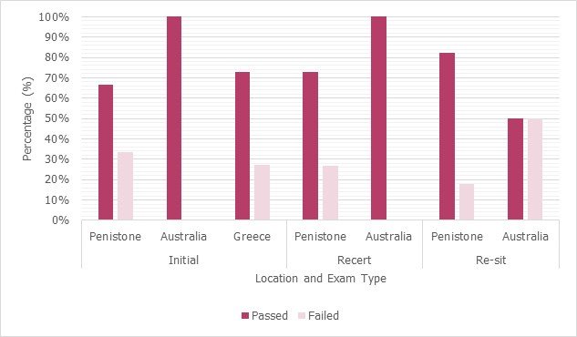
Total number of candidates:
Location | Initial | Recert | Re-sit
Penistone | 81 | 26 | 28
Australia | 21 | 2 | 8
Greece | 11 | 0 | 0

Magnetic

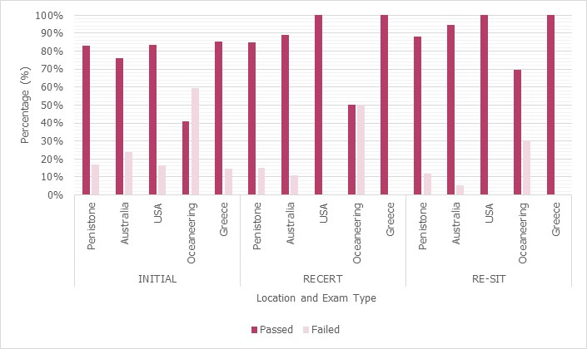
Total number of candidates:
Location | Initial | Recert | Re-sit
Penistone | 283 | 160 | 67
Australia | 76 | 9 | 19
USA | 12 | 2 | 1
Oceaneering | 27 | 22 | 33
Greece | 27 | 7 | 1

Penetrant

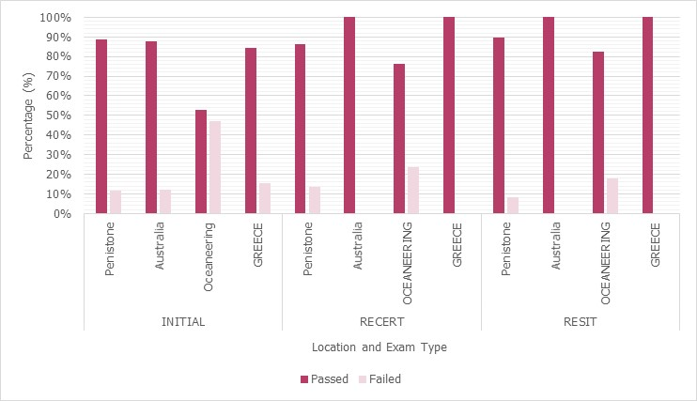
Total number of candidates:
Location | Initial | Recert | Re-sit
Penistone | 254 | 132 | 48
Australia | 65 | 5 | 7
Oceaneering | 36 | 17 | 17
Greece | 32 | 5 | 3

Radiographic Testing

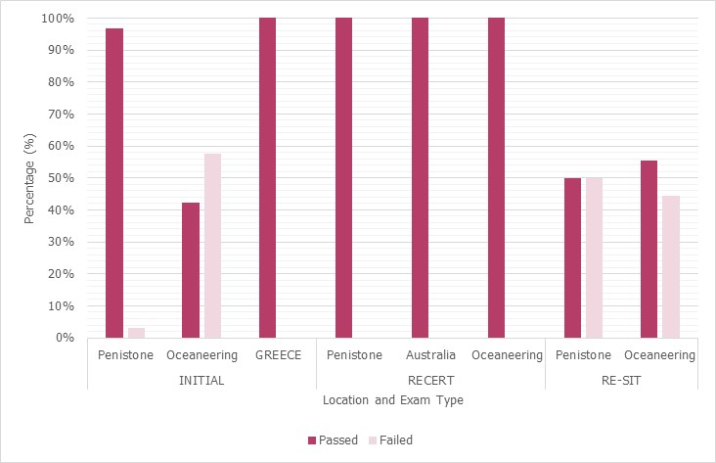
Total number of candidates:
Location | Initial | Recert | Re-sit
Penistone | 62 | 61 | 4
Australia | 0 | 1 | 0
Oceaneering | 26 | 8 | 9
Greece | 8 | 0 | 0

Radiographic Interpretation

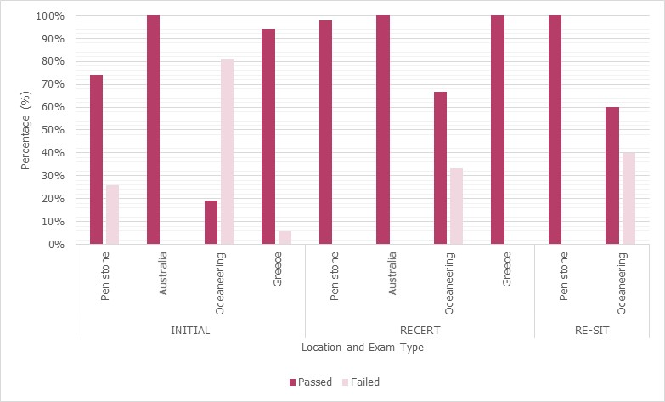
Total number of candidates:
Location | Initial | Recert | Re-sit
Penistone | 81 | 44 | 25
Australia | 10 | 3 | 0
Oceaneering | 21 | 3 | 15
Greece | 17 | 1 | 0

BRS

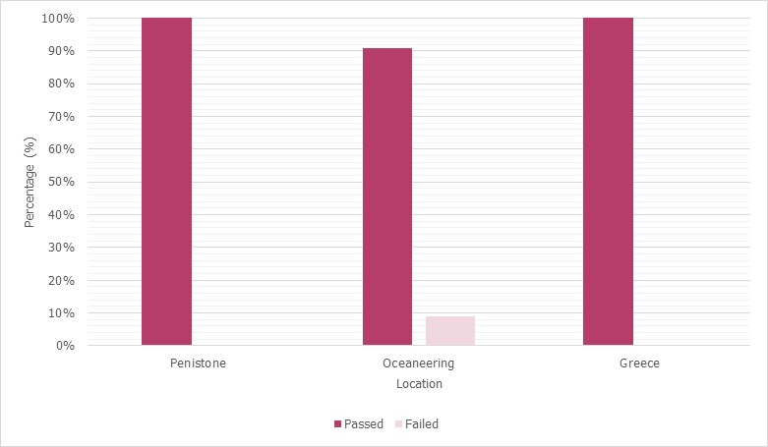
Location | Total number of candidates
Penistone | 149
Oceaneering | 55
Greece | 11

RPS

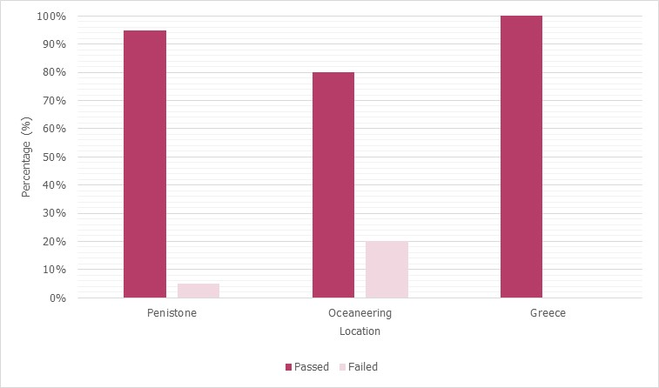
Location | Total number of candidates
Penistone | 40
Oceaneering | 5
Greece | 2

Visual Testing

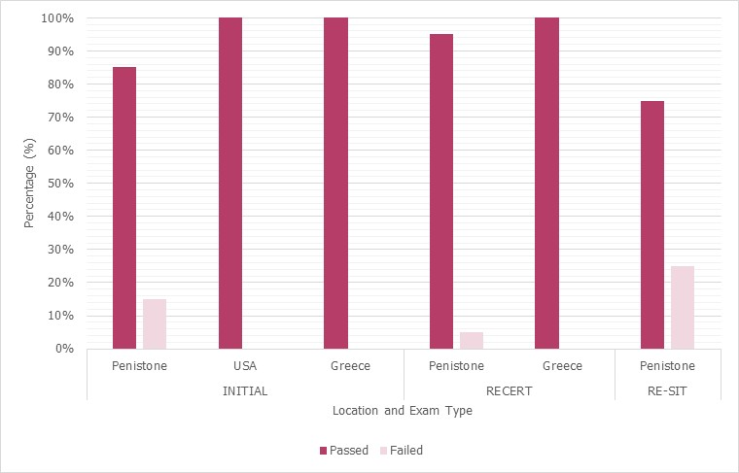
Total number of candidates:
Location | Initial | Recert | Re-sit
Penistone | 80 | 20 | 16
USA | 1 | 0 | 0
Greece | 17 | 0 | 0

Phased Array

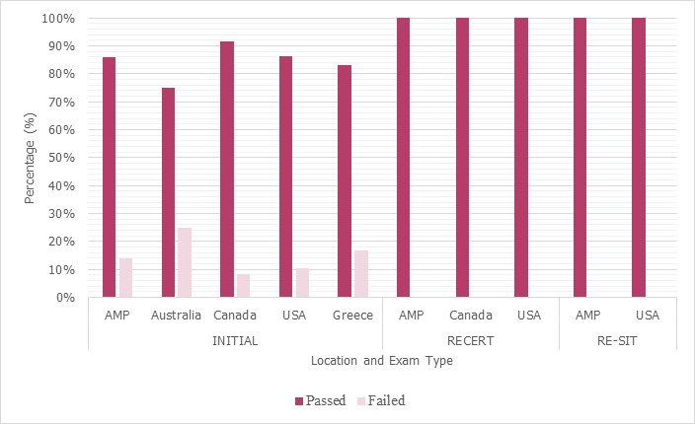
Total number of candidates:
Location | Initial | Recert | Re-sit
AMP | 36 | 13 | 3
Australia | 4 | 0 | 0
Canada | 24 | 1 | 0
USA | 29 | 1 | 2
Greece | 6 | 0 | 0

TOFD

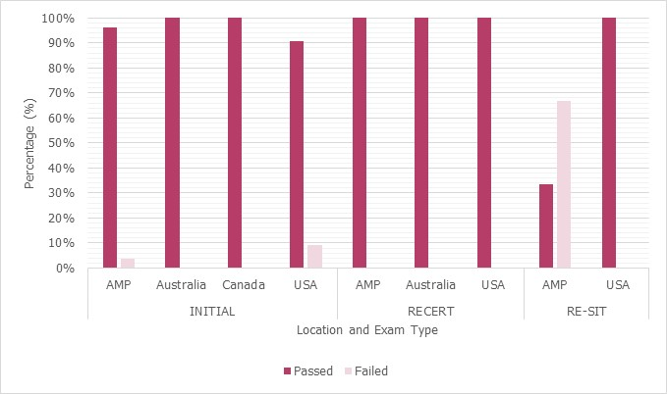
Total number of candidates:
Location | Initial | Recert | Re-sit
AMP | 26 | 16 | 3
Australia | 6 | 1 | 0
Canada | 8 | 0 | 0
USA | 11 | 2 | 1

Ultrasonic Testing of Welds

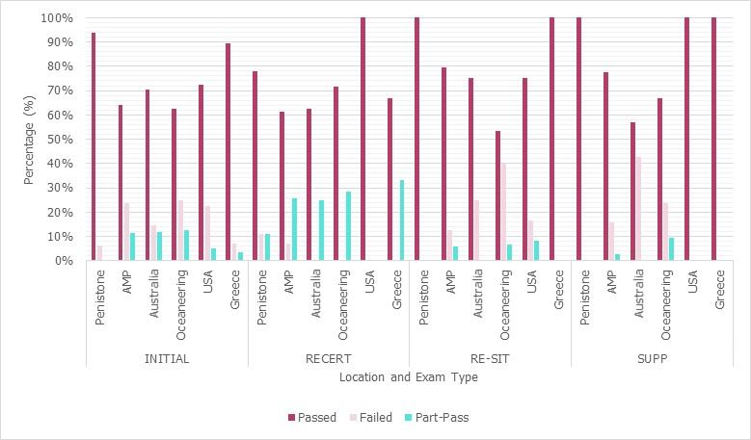
Total number of candidates:
Location | Initial | Recert | Re-sit | Supp
Penistone | 16 | 9 | 4 | 2
AMP | 139 | 98 | 88 | 115
Australia | 34 | 8 | 8 | 7
Oceaneering | 32 | 7 | 15 | 21
USA | 40 | 2 | 12 | 3
Greece | 28 | 3 | 2 | 1

Ultrasonic Testing of Forgings

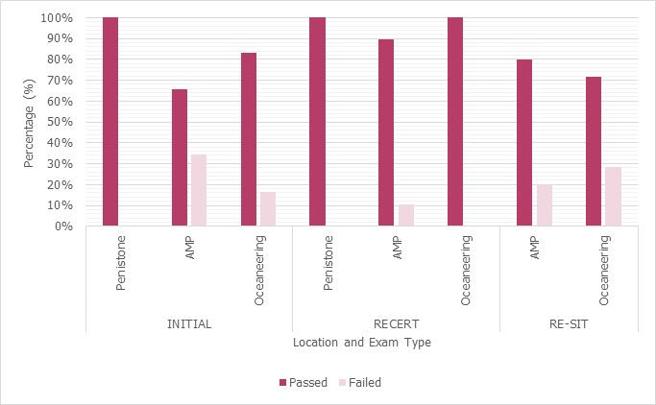
Total number of candidates:
Location | Initial | Recert | Re-sit
Penistone | 4 | 3 | 0
AMP | 38 | 29 | 15
Oceaneering | 12 | 1 | 7

Ultrasonic Testing of Castings

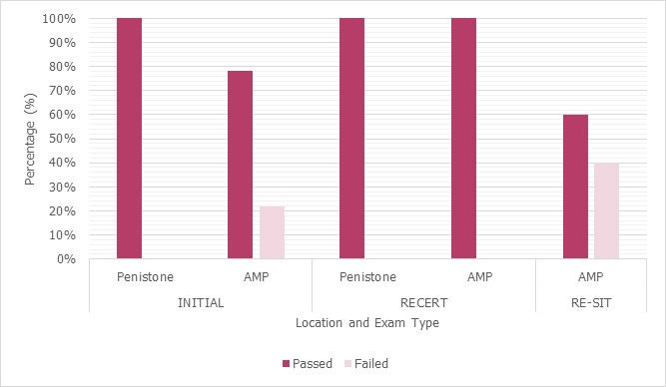
Total number of candidates:
Location | Initial | Recert | Re-sit
Penistone | 1 | 1 | 0
AMP | 23 | 13 | 5

Ultrasonic Testing Critical Sizing

Total number of candidates:
Location | Initial | Re-sit
AMP | 18 | 3
Oceaneering | 5 | 0

Refer to Appendix A7 document QD 132 Issue 1 for the list of potential actions needed and corresponding codes
Refer to Appendix A8 document QD 131 PCN Folder Check List; Appendix A9 document QD 133 PCN Folder Information Sheet; Appendix A10 document QD 143 Daily Training Assessment Workbook Information Sheet

